Canopy 🌳🌳🌳 - UX Brief
The purpose of this document is to define the UX problem space, provide effort estimates and assist in project planning.

1. Project at-a-glance
*Final UX delivery date and GA date are auto-populated from the table in 6. Schedule estimation.
Summary
Author of doc (UXD) | James Y. Huntley
Date of last update | 1/29/2025
Project name | Canopy
AWS service | Control services
Short description | Project Canopy improves the efficiency for approving and adopting AWS services. Canopy provides a ready-made threat model tailored to the APIs and processes for each AWS service. Each threat model has known mitigations and provides customers recommended AWS managed controls that customers can easily enable in order to provide the proper guardrails ahead of onboarding that service. Following the assessment, the UX provides a dashboard that allows customers to monitor for new threats and control updates.
Size | Large
Tracking
Asana intake ticket link | https://app.asana.com/0/1205919681573609/1207270083379310
Asana project link | https://app.asana.com/0/1207574882352898/1207574992106116
Slack primary UX channel | #prj-canopy-ux
Tier | Tier 1
Final UX delivery date* | Jun 16, 2025
GA date* | Dec 1, 2025
Stakeholders
Product manager | Arnaud Coulondre
Program manager | n/a
Engineering team | SDE: Alessandro Arici (backend); Zach Polsky (console)  SDM: Peng Fu; Controls lead: Benjamin Feldon, SDM: Kyle O'Connor
UX designer | James Y. Huntley
UX researcher | Harshali Wadge
Tech writer | Leslie Lundquist

2. Project Goal
The primary goal of Project Canopy is to assist customers in approving and allow-listing AWS services more efficiently and with greater confidence. To achieve this, Canopy delivers an intuitive and easy-to-use management console UX for a customer to discover threat models relevant to the desired AWS services, view mitigations to those threats and directly enable AWS managed controls that will provide the customer with the desired governance outcomes for their environment.

The experience should be intuitive and easy to understand for both veteran and early adopters to governance controls, and most importantly: comprehensive. Canopy provides a comprehensive solution to governance at service onboarding, and addresses the fundamental question: “When am I safe?”.

Definitions:
- Threat model: An identification about potential security, access and governance threats that may be exposed by processes that are part of the AWS service.
- Mitigation: An action that can be taken to reduce the likelihood or impact of an identified threat. Unlike a “remediation”, this action is taken before the threat is actualized.
- Control: A pre-packaged governance rule that can be applied to specific groups of AWS accounts or enterprise-wide. AWS managed controls are controls that are owned by services including Control Tower, Security Hub and Config and may be preventative, detective or proactive.

2.0a Examples of generic threats that may surface include:
 | A | B | C
1 | Threat | Property | Definition
2 | Spoofing | Authentication | Impersonating something or someone else
3 | Tampering | Integrity | Modifying data or code
4 | Repudiation | Non-repudiation | Claiming to have not performed the action
5 | Information Disclosure | Confidentiality | Exposing information to someone not authorized to see it
6 | Denial of Service (DoS) | Availability | Deny or degrade service to users
7 | Elevation of Privilege | Authorization | Gain capabilities without proper authorization

3. User personas

Image | Persona | Avatar name | Primary goal | Primary opportunity with Canopy
 | Security Engineer Lead | Tim | To safeguard access, manage the uber security of the organization and interpret information across policies, documentation, logs, and other tools linked to all company accounts to verify that we are compliant with company requirements. | Canopy speeds up our security posture (including TM, Mitigations and controls) of desired AWS services by replacing manual threat modeling with models relevant and specific to AWS servicess. We no longer need to create or research controls becomes they are prescribed in a couple clicks within the same UX. The plaftform change analyzer ensures our controls are up-to-date and we have a point of action when we are alerted to changes in AWS service-based threat models, mitigations or controls.
 | Cloud platform architect  (aka Cloud Implementer) | Sam | To design and maintain a secure infrastructure through a combination of policies, compliance and governance controls. | Canopy allows me to onboard to the cloud solutions of AWS services by increasing the speed of compliance and security approvals.

4. UX narrative (problem and solution)

“Tim is a security lead who needs to identify potential threats of an AWS service and easily discover controls that mitigate those threats before the AWS service can be allowlisted for use.”

4.1 Problem and opportunity
CitiBank has been very interested in Amazon Bedrock for it’s foundation models (FM) and serverless model to add generative AI into its apps with reduced cost and infrastructure. The IT department has received the necessary approvals from leadership and are ready to begin the onboarding process.

Sam is a cloud platform architect for CitiBank and wants to be sure they onboard Bedrock securely and with the best possible compliance. Sam makes a note to call Tim, who is the head of security engineering to begin scheduling the review. “I wonder how long this is going to take,” Sam thinks to herself remembering that the last assessment had taken 12 months. Sam reflects on that past process: first, there were the deep-dive into AWS documentation and several conversations between their security engineers and the AWS representatives in order to establish the processes. Then each of those processes were researched for potential threats processes that would contradict CitiBank’s policies. And finally, after several reviews, there were lengthy support discussions to decide on the best mitigations. The cloud platform architects invested time sourcing through the available AWS managed controls to get the desired outcomes. By the time the service was in the hands of the engineers, 12 months had passed.

Tim answers the phone form the security engineering office in the IT department: “Hey Sam, yeah I heard we got the approval to onboard to Amazon Bedrock, that’s really exciting! This would be a great opportunity to test out Canopy.” “What’s Canopy?” Sam asks. Tim goes on to explain to Sam how Canopy is an AWS service to facilitate efficient onboarding to AWS services by providing ready-made threat models and recommending AWS managed controls in a few clicks. “The removal of the manual threat analysis frees my team up which is already at their limit, and we can get Bedrock into the hands of our users for the upcoming financial portfolio app they are planning,” Tim says. “That’s amazing, let’s get started!” Sam exclaims.

4.2 Solution
4.2a A diagram of the threat analysis and monitoring can be found in the following diagram (Click here for full Figjam diagram)
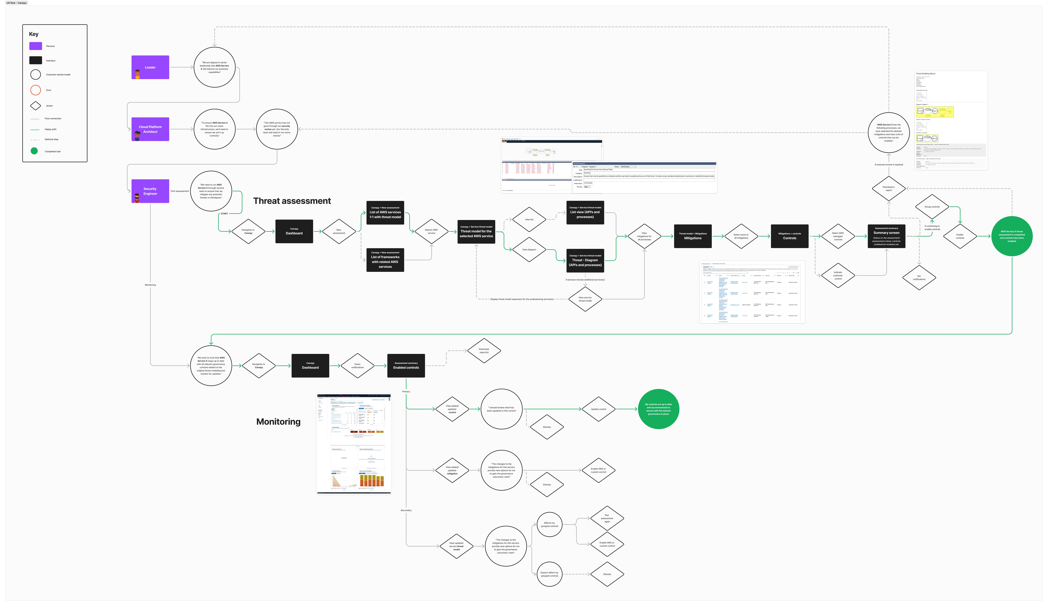

4.2.1 Performing threat analysis on an AWS service
Tim navigates to the Canopy dashboard within the Control Tower console. It’s a familiar UX because his team often ends up in Control Tower’s controls library when researching AWS managed controls during manual threat analysis.

Each AWS service has a threat model
From Canopy’s interface, Tim searches for Amazon Bedrock from the list of available AWS services, and upon selection, he is presented with the model. The screen displays a data flow diagram (DFD) that visualizes the processes and API calls of the AWS service. He is able to click and view various threats. As an example, one of the threats is categorized as “Information disclosure” and reads: “This action may exposing information to someone not authorized to see it.”

Control mapping to mitigations
Tim chooses to view the mitigations for the threats is presented with a list of mitigating action, some of which that he notes are not actions that CitiBank needs addressing or has has already addressed. As Tim selects the desired mitigations, he is presented with a list of AWS managed controls categorized by the different mitigating actions. As an example, one of the preventative controls is an SCP template for managing access to the feature by accounts in his organizational unit (OU). “This just saved me weeks of investigative work!” Tim thinks to himself.

AWS managed controls customer groups
After selecting all relevant AWS controls, Tim has the option to ‘group the controls’ either in a new group or to add them to an existing group of controls. Tim creates a new group, and calls it “Bedrock“. "Great, now I’ll be able to know which controls were part of this specific service and I can keep them organized!"

Support for customer managed control
For one of the mitigations, there are few AWS managed controls available, but he sees there is an option to ‘Add customer managed control’. Tim’s security team had built some additional controls that were authored specifically for CitiBank, and doesn’t want there to be any gaps in their compliance. Tim adds the control and continues in the assessment.

Summary and report
At the end of the threat analysis, Canopy provides a single summary of the controls that were enabled and provides the option to download a report. Tim exports the report to share with his leadership and the control list with Sam for implementation. Based on the easy-to-understand threat model, and the known mitigating controls, Sam can approve Amazon Bedrock for implementation and onboard CitiBank to the service. The end to end process with Canopy was only 4 weeks!

4.2.2 Cloud platform change monitoring
A short time later, Bedrock has been successfully deployed into the hands of CitiBank users. “Canopy made the onboarding process so much easier!” thinks Tim, “But, I want to be sure we stay on top of the new service to ensure it stays compliant.” Tim’s team has been telling him about the new platform change analysis dashboard in Canopy, and he is eager to take a look.

Dashboard and notifications
Tim navigates to Canopy, and within the new dashboard, he sees a table of notifications, categorized by the following ‘types’: threat, model and controls. He also sees he can filter the list of notifications by the group he created “Bedrock onboarding”, or by AWS services that are enabled by his AWS organization. Tim sees there are two alerts. One is of the type “threat” and one is on the type “control”. Clicking into the ‘threat’ update, he is presented with a notification stating: “a new mitigation is available for review that assists in addressing this treat.” Tim clicks on that notification and is presented with additional recommended mitigations and a control. He decides this is not a mitigation he is concerned about, and from the actions selector he chooses to ‘Dismiss’ the alert.

Updating AWS controls
He then clicks on the notification for the ‘control’ notification, and reads: “There has been an update to a parameter in this control’s API.” Tim chooses to view the update and views the control detail page to view the updates. “I love how I can set it and forget it!” Tim thinks to himself.

5. UX scope

a. Designs
Canopy UX will surface new API’s, and a new ontology that will benefit from the centralized Control Catalog API, and provide new mappings of threat models to services, threat models to potential mitigations (actions), and those actions to AWS managed controls. The UX is assumed at this time to live within the Control Tower management console. UX summary is as follows:
- Console UX for threat modeling, mitigation and controls:
  - AWS service list with 1:1 link to threat models
  - Threat models mapped to existing mitigations (actions customer can take)
  - Mitigations are mapped to AWS managed controls customer can enable or disable
  - Add ability for customers to include their own customer managed controls for mitigations
  - Capability of customers to create groups or add controls to existing groups that allow for future management of those controls against the services that are onboarded
- Console UX for ongoing monitoring of controls connected to threats
  - Updates when controls have a new version or require update
  - Updates on updated threat model and related mitigations
  - Updates to potential mitigations and impact to controls

b. UX research needs

Research needed | Yes | No | Notes
Customer interviews | ✅ |  | What is the duration for customers to onboard today and what regulatory compliance agencies are most often the cause of delay due to need to find the necessary controls. Would also be good to understand a competitive landscape if there are external tools to AWS that are being used or similar tools from other providers (e.g. Azure)
Usability testing | ✅ |  | Necessary for new threat modeling behavior
A governance-focused threat modeling feature/service does not exist today. We will also need to ensure the customers can map the surfaced threat models to mitigations easily with the relevant controls. We will also need to know which common threats customers are employing customer managed controls.

c. Related projects
- Project Hippogriff: Centralization of all AWS managed controls into a single repository that is centrally managed with a common ontology (categorization with relationship properties) and distributes controls via a meta data widget for consistent display. First consumers will be (GA December 2024)

6. Schedule estimation
Estimations are high-level, and for planning purposes only.
- Start date: Jul 15, 2024
- Total effort estimate: 20.1 weeks
- Final designs hand-off: Jun 16, 2025
 | A | B | C
1 | Effort and task summaries | Est. weeks | ECD
2 | UX Designer begins effort on project |  | Jul 15, 2024
3
4 | Planning
5 | UX brief and deep-dive into CX problem | 1 | Aug 1, 2024
6 | PR/FAQ support (graphics and collaboration with PM) | 1 | Oct 31, 2024
7 | UX kick-off meeting with project stakeholders | 0.2 | Jan 29, 2025
8
9 | Generative research
10 | Look though past research and consult, product and SMEs | 0.4
11 | Prep and conduct customer research study | 0
12
13 | Designs (directional)
14 | Create user flow diagram | 0.2 | Aug 1, 2024
15 | Create lo-fi wireframes | 0.2
16 | Create hi-fi directional designs | 2 | Feb 13, 2025
17 | Review designs with UX team and edit | 1 | Feb 20, 2025
18 | Review designs with project stakeholders and edit | 2 | Feb 27, 2025
19 | Review with partner service teams and edit | 1
20 | Review directional designs during a UX Milestones Deep Dive | 0
21
22 | Validation
23 | Prep UX validation study (e.g. usability testing) | 3 | Apr 18, 2025
24 | Conduct UX validation study, sythensize and share insights | 2 | May 2, 2025
25
26 | Designs( finalize)
27 | Align with project stakeholders and service partners | 2 | May 16, 2025
28 | Sign-off with IDCG UX managers or UX leads | 1 | May 23, 2025
29 | Sign-off with IDCS leadership (required for tier 1 and tier 2 projects) | 2 | Jun 6, 2025
30 | Sign-off with UX Milestones program (required for tier 1 and tier 2 projects) | 0.5 | Jun 11, 2025
31 | Final designs hand-off | 0.4 | Jun 16, 2025
32
33 | Implementation
34 | Bug bash and dev support leading to Fit & Finish with project team | 0.2
35 | Fit & Finish with UX Milestones program (required for tier 1 and tier 2 projects) | 0.2
36
37 | Estimated effort subtotal and GA date | 20.1 | Dec 1, 2025

7. Related links

7.1 Project documents
- (Arnaud) PR/FAQ: Canopy PRFAQ
- (Arnaud) Governance Strategy doc: https://amazon.awsapps.com/workdocs-preview/index.html#/document/9055ef14c52813f5f363e782101331815d065d119196042e0c9c691ee916437d
- (Arnaud) Control coverage doc: https://amazon.awsapps.com/workdocs-preview/index.html#/document/eba2364c36c9b061494d2f256e833165c490b5d76f543cbada4357dde1ab9d6a
- (Arnaud) Control production operating model: https://amazon.awsapps.com/workdocs-preview/index.html#/document/1f806e300ab753b34dac43dad59cbec1dd38e155b90bd3ddad1f6e4fe23b9f30
- (Arnaud) Preventive control strategy doc: https://amazon.awsapps.com/workdocs-preview/index.html#/document/601068353059f10a2da5989d2b4b47181b7ddaf21a05a72de83ef872507ee456

7.2 Related articles and products
- Azure Microsoft Threat Modeling Tool:
  - https://learn.microsoft.com/en-us/azure/security/develop/threat-modeling-tool
  - https://learn.microsoft.com/en-us/azure/security/develop/threat-modeling-tool-getting-started
- External solution: Arctic Wolf: https://cybersecurity.arcticwolf.com/AWS-FY25.html?utm_source=Google&utm_medium=CPC&utm_campaign=ADV%20FY25%20CPC%20NA%20Google%20Search%20AWS&cq_plac=&cq_net=g&cq_pos=&cq_med%20=&cq_plt=gp&gad_source=1&gclid=Cj0KCQjwv7O0BhDwARIsAC0sjWMGEDacKPb9YjA0vDttltA250xvffpJHxRFWJ7XvUmd2ojI5VuHL1AaAm5SEALw_wcB
- AWS: How to approach threat modeling: https://aws.amazon.com/blogs/security/how-to-approach-threat-modeling/
- Threat model for Bedrock: https://aws.amazon.com/marketplace/pp/prodview-obz63lhcdnono

Published using UX Brief template version 3.0 | 01.06.25

